39.29: a) 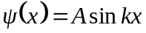. The probability density is 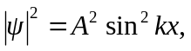 and this is greatest when 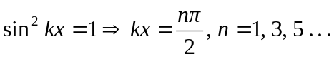
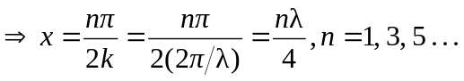
b) The probability is zero when 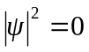, which requires
